**IGNACIO CARREON CARRASCO**

**DATA MODELLING AND DATABASES**

**ASSESSMENT 3**

**ERD**

**STRONG ENTITIES**

Department **DepartmentID pk**

Doctor **DoctorID pk** Name Address Email Phone

Nurses **NursesID pk** Name Address Email Phone

Compounders **CompoundersID pk**

Rooms **RoomsID pk**

Working Staff **WorkingstaffID pk** Name Address Email Phone

Patient **PatientID pk** Name Address Email Phone

**WEAK ENTITIES**

Regular **RegularID pk**

Admitted **AdmittedID pk**

Operated **OperatedID pk≠**

Discharged **DischargedID pk**

Private **PrivateID pk**

General **GeneralID pk**

Call on **CallonID pk**

Regular doctor **RegulardID pk**

Visit **VisitID pk** Date Time

Check up **CheckupID pk** Notes

**RELATIONSHIP**

**ONE TO ONE**

**Visit VisitID pk Check Up CheckupID**

**ONE TO MANY**

Departments **DepartmentID pk**

Patient **PatientID pk** Name Address Email Phone

**MANY TO MANY**

**Doctor DoctorID pk** Name Address Email Phone  **Patient** PatientID pk Name Address Email Phone

**MULTIVALUED ATTRIBUTE**

Regular **RegularID pk PatientID fk pk**

Admitted **AdmittedID pk PatientID fk pk**

Operated **OperatedID pk≠ PatientID fk pk**

Discharged **DischargedID pk PatientID fk pk**

Private **PrivateID pk RoomID fk pk**

General **GeneralID pk RoomID fk pk**

Call on **CallonID pk DoctorID fk pk**

Regular doctor **RegulardID pk DoctorID fk pk**

DIAGRAM

≠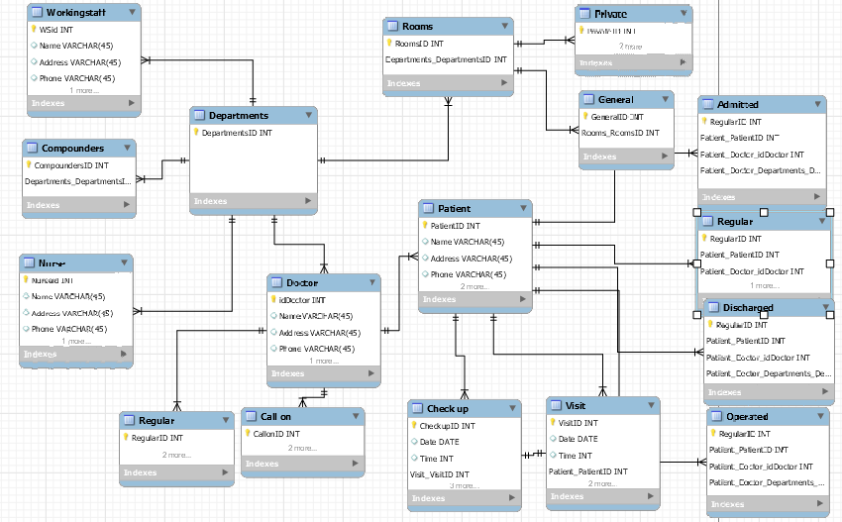

LOGICAL ERD

